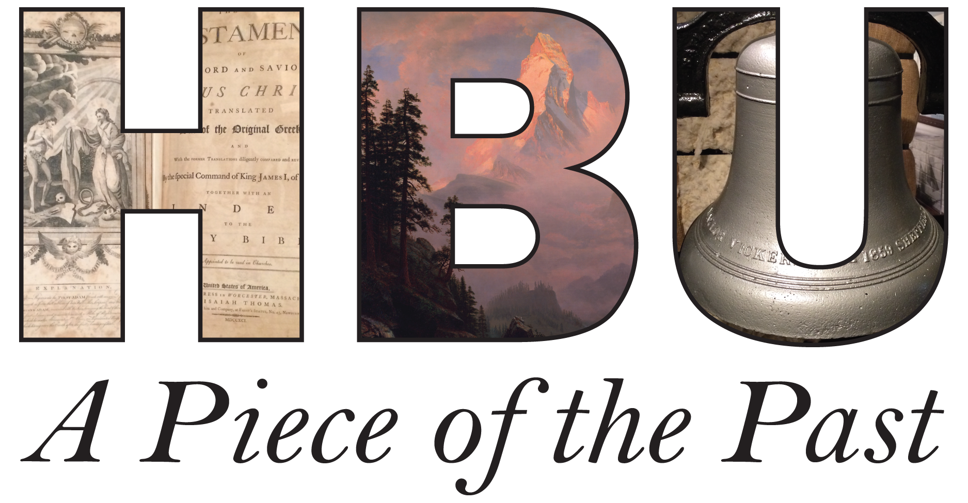
REQUIREMENTS
“A PIECE OF THE PAST” MUSEUM ESSAY CONTEST
2017-2018
Essay Guidelines

Due Date Friday, March 23, 5:00PM CST

Format

Font: Times New Roman, 12pt
Spacing: Double
Margins: 1” all around
Length: 1,000-1,250 words (including title page, works cited page/notes)
Page Numbers: Upper right corner

Cover Sheet
The cover page should include the following information:

Full Name
H#
Email address
Museum Category (“Southern/Decorative,” Dunham,” “Art,” or “Academy”)
Freshman or Academy status (if applicable)
Name of Artifact or Artwork
Word Count (you may include or exclude the cover sheet, title, and citations in
determining word count)
Title of Essay (centered on page)

First Page of the Essay

The first page of the essay should repeat the essay title but should not include any other identifying information. The text of the essay should begin 2” down the page. Do not include your name on the first page or any subsequent page of the essay.

Electronic Submission

To submit your essay, you must be enrolled in a special “Museum Essay Contest” course page on Blackboard. If you do not already see the course on your Blackboard page, follow these instructions to enroll: Step 1: Go to “hbu.blackboard.com” and login with your HBU OneLogin information. Step 2: Click on the “My Courses” tab and find the “Course Search” navigator. Step 3: Type in the course “Museum Essay Contest.” Step 4: Once the course pops up, click the drop box next to the class name and select ‘Enroll’ (pick “Org 2” if “Org 1” also appears). Step 5: Select ‘Submit.’ Step 6: You’re In! Once you are enrolled, select the Contest 2017-2018 folder and submit your paper to the appropriate category folder.

References/Citation Styles
You may use any of the standard citation styles such as MLA, Chicago, or Turabian. Whichever you choose, be sure to use it consistently throughout the essay. The essay should include a Works Cited page or a Bibliography page, as required by the chosen style. Such a page alone, however, does not count as sufficient citation. Each piece of information in your essay must be properly sourced, either in a footnote, endnote, or parentheses in the body of the essay.

ESSAY THEMES

Southern History Museum, Museum of American Architecture and Decorative Arts, and Dunham Bible Museum
For these museums, your essay should combine knowledge of the artifact itself with an understanding of its broader historical context and significance. Your ultimate aim should be to enhance the viewer’s appreciation of the artifact.

In preparing your essay, please consider the following:

1. The artifact as a physical object: What is your artifact made of?

What is its size, shape? When was it made? For whom was it made? For what purpose was it made? Is this a unique piece or one of many? Who has owned it?

2. The artifact in historical context: What broader historical trend does your artifact illustrate?
What particular historical event has it played a role in? What prevailing cultural value does it express?

3. The artifact as a museum piece: What impression does the artifact make upon you as a museum piece? How might that impression differ had you encountered it in its original historical setting?

Fine Arts Museum and Contemporary Art Gallery
For the art category, write on one of the artworks in the Fine Arts Museum or the Contemporary Art Gallery. Please consider the following:

1. The period in which the work was created, the style, and the historical context.
2. The artist and the most likely intent of the work.
3. In what ways does this work demonstrate the properties of Beauty that come to us from Plato, Aristotle and Aquinas: Proportion, symmetry, integrity of design, clarity, and unity?
4. In what way does this work demonstrate Truth or Goodness?
5. How does this painting portray the essence of Christ and His teachings? Is it effective?
***Please consult the readings on Truth and Beauty available at hbu.edu/museums.***

JUDGING CRITERIA

In judging the essays, the judges will take into consideration the following:
1) Requirements: (Does the essay conform to all the requirements?)
2) Grammar: (Is the essay grammatically correct?
3) Style (Is the writing clear and in good style?)
4) Thesis Statement (Is the thesis statement clear?)
5) Organization (How clear and coherent is the organization of the essay?)
6) Historical Context/Significance (How clearly and effectively does the
essay explain the object’s historical context and its significance as an artifact/art?)
7) Research (How substantial and effective is the research presented in the
essay?)
The judges reserve the right to disqualify essays that do not meet the basic requirements as to format, presentation, and citation explained above.

[COVER SHEET SAMPLE]
James D. Johnson
H#000555555555
jdjohnson@hbu.edu

Dunham

Freshman

“Gullah Bible”
1,027 words

“Jesus Feed a Whole Heapa People”: The Gullah Bible of 2005

[FIRST PAGE SAMPLE]

“Jesus Feed a Whole Heapa People”: The Gullah Bible of 2005

[Begin text of the essay here.]

