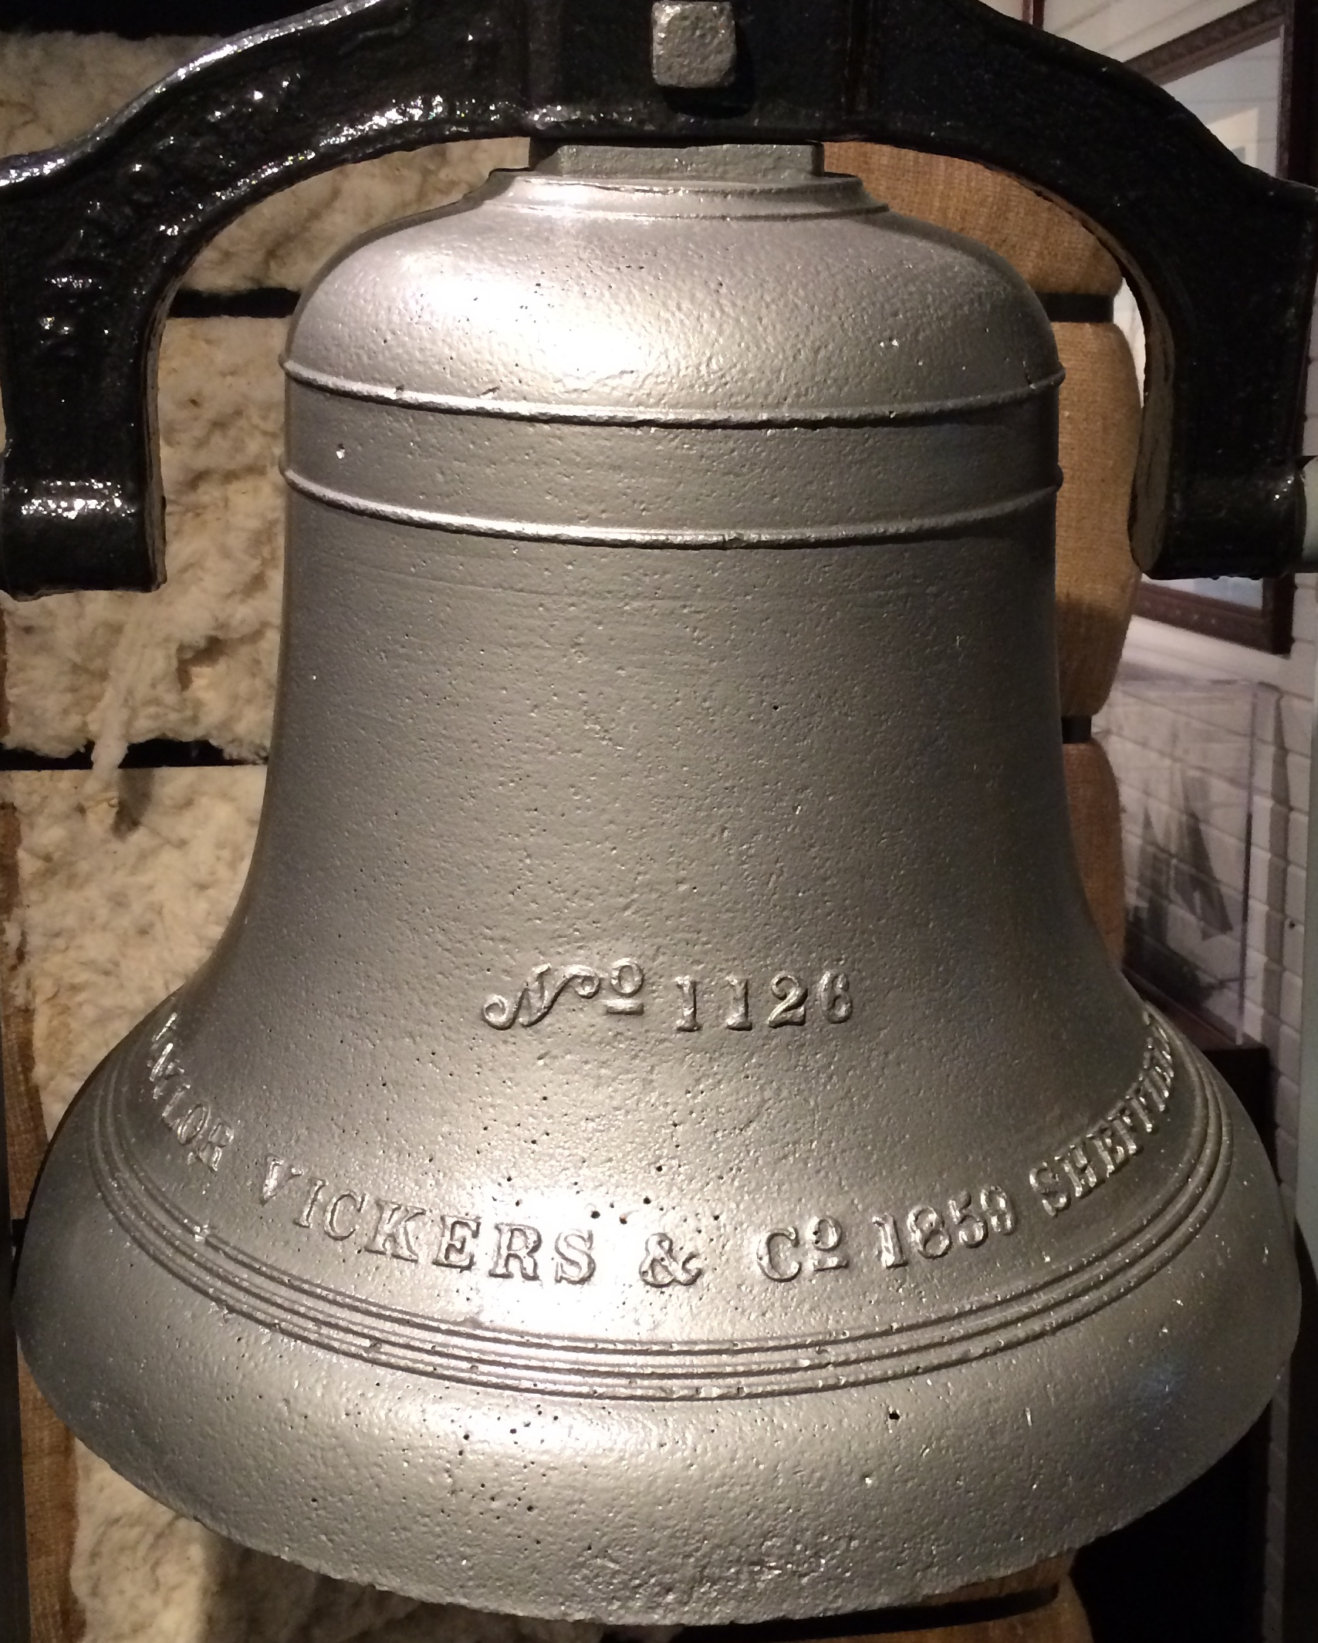
ANNOUNCING HBU’S 7th ANNUAL
“A PIECE OF THE PAST”
UNIVERSITY MUSEUM ESSAY CONTEST, 2016-2017

The Museum of Southern History • The Dunham Bible Museum • The Museum of American Architecture and Decorative Arts • The Fine Arts Museum • Contemporary Art Gallery
{
GRAND PRIZE
$1,500
}

Plus ADDITIONAL PRIZES IN FIVE CATEGORIES:

1. Museums of Southern History & Decorative Arts 1st place: $500 2nd place $250
2. Dunham Bible Museum 1st place: $500 2nd place $250
3. Fine Arts /Contemporary Art Museums 1st place: $500 2nd place $250
4. Best Freshman/HBU Academy Essays 1st place: $500 2nd place $250

And
An Invitation for Each Winner to the
Awards Dinner
All HBU and HBU Academy students eligible!

For further details,
see back!
ELIGIBILITY: All current HBU and HBU Academy students (including HBU December 2016 graduates) eligible for categories 1-3 and the grand prize. HBU undergraduate freshmen and HBU Academy students eligible for category 4. Submission deadline is February 17, 2017!

HOW TO ENTER

1. CHOOSE AN ARTIFACT OR ARTWORK: You may choose any artifact or work of art in any of the five museums. Excluded are explanatory displays, facsimiles and reproductions. Museum staff will be available to help orient students to the museum collections and to discuss possibilities. The Museum of Southern History, the Dunham Bible Museum, and the Museum of American Architecture and Decorative Arts are all located in the Joella and Stewart Morris Cultural Arts Center. The Fine Arts and Contemporary Art museums are located in the University Academic Center (UAC).

2. WRITE THE ESSAY: Write a 1,000 to 1,250-word essay on your chosen artifact or artwork. Full essay guidelines are available at www.hbu.edu/museums or from Dr. Anthony Joseph at ajoseph@hbu.edu. The essay deadline will be Friday, February 17, 2017, 5pm.

3. SUBMIT THE ESSAY: To submit your essay, you must be enrolled in the “Museum Essay Contest” course page on Blackboard. If you do not already see the page on your Blackboard site, follow these instructions to enroll in the course: Step 1: Go to “hbu.blackboard.com” and login with your HBU OneLogin information. Step 2: Click on the “My Courses” tab and find the “Course Search” navigator. Step 3: Type in the course “Museum Essay Contest.” Step 4: Once the course pops up, click the drop box next to the class name and select ‘Enroll’ (pick “Org 2” if “Org 1” also appears). Step 5: Select ‘Submit.’ Step 6: You’re In! Once you are enrolled, select the Contest 2016-2017 folder and submit your paper to the appropriate category folder.
4. AWAIT JUDGMENT. The judges will evaluate the essays (including quality of the scholarly research, argument, organization, writing style, and documentation). The judges reserve the right to disqualify essays that do not meet the basic minimum requirements described in the essay guidelines.
PLEASE ALSO NOTE…

FRESHMAN/HBU ACADEMY CATEGORY: The winning freshmen/Academy essays will be selected from the essays submitted in the three museum categories. Freshman status will be accorded to students with fewer than 32 earned college credit hours at the beginning of Fall 2016. Any student enrolled in the HBU Academy for either semester of the 2016-2017 academic year is eligible for this category.

NUMBER OF SUBMISSIONS: Students may submit up to three essays but no more than one in a single museum category.

AWARDS DINNER: The winners will be invited to an Awards Dinner to be held in March 2016. The winner for each specific prize, including the grand prize, will be announced at the dinner.

FOR MORE INFORMATION… Visit the museums or the museum website at www.hbu.edu/museums. Or contact Dr. Anthony Joseph at ajoseph@hbu.edu.

