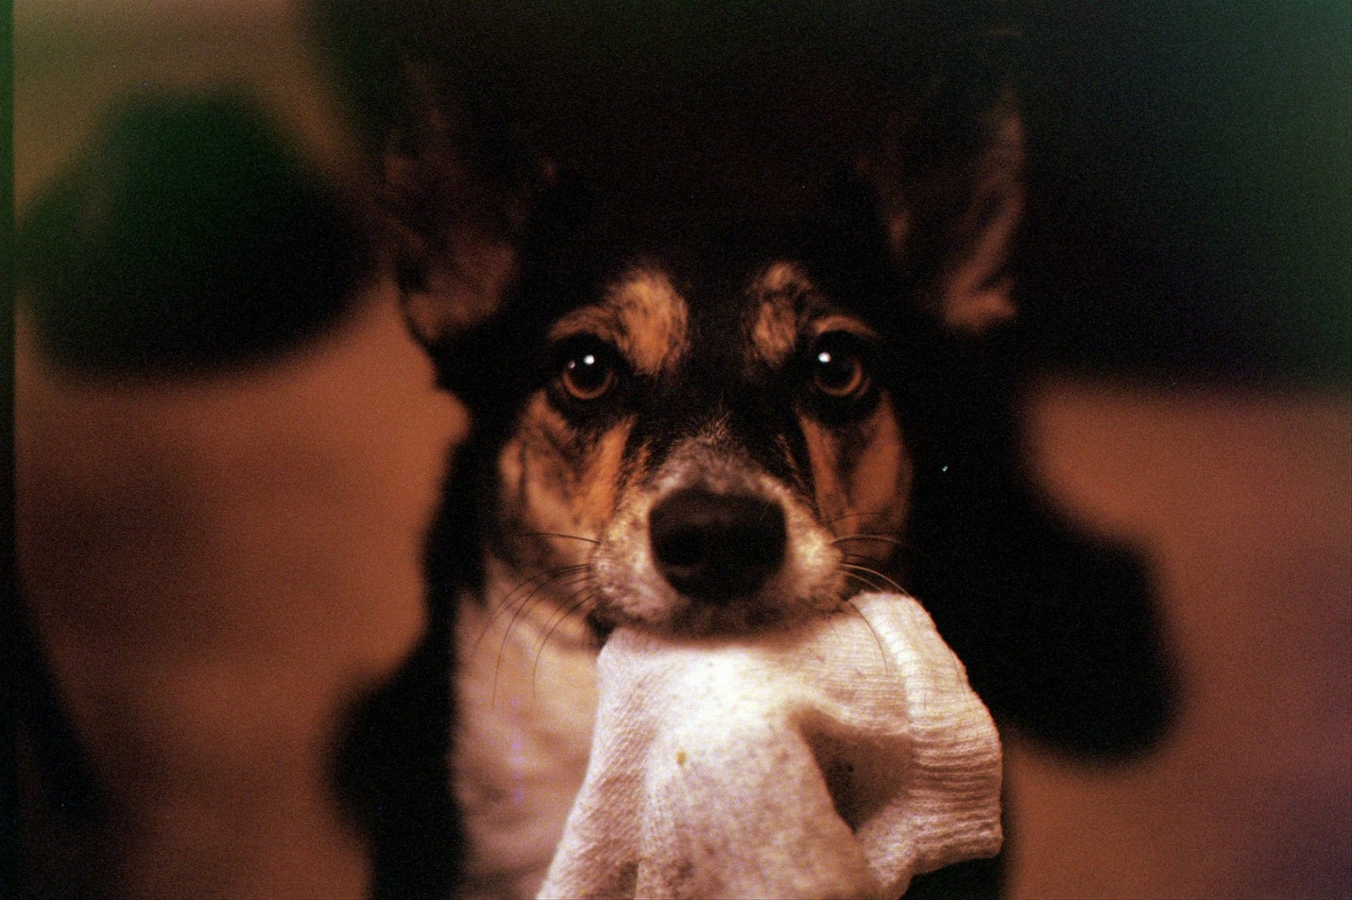

In "Priceless Gift," a dog offers her owner, and invariably the viewer, a sock. But is the titular "priceless gift" the sock, or the dog and her companionship and love which she extends to her human? Or is it a good and well-fed life bestowed to this lowly animal, an act which eternally supersedes the dog's measly attempts at reimbursement? There's a parallel here to God and His infinite blessings; the dog a symbolic stand-in to the meager repayments of mankind, which register symbolically, not materially.

